Experiment 6
Bipolar Junction Transistor (BJT) Circuits: Inverter and Common Emitter Amplifier

Introduction
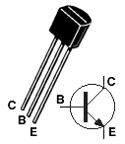BJTs are extensively used in all types of electronic circuits. The aim of this part of the experiment is to familiarize you with the basic modes of operation and features of a BJT through the study of simple BJT circuits. The BJT that you will be using in this experiment is BC 547 (the pin diagram is shown in Fig.1), which has a typical current rating of 100 mA (maximum). Make sure to connect the transistor correctly in the circuits. Also, while changing any component in the circuit, please turn the power supply off, and turn it on again only after all the required changes have been made and the circuit is complete.
Fig.1
BJT Inverter Circuit
BJT inverter circuit is commonly used to implement the NOT function (i.e., the output is an inverted form of the input) using discrete BJTs. The circuit also illustrates the basic modes of operation of a BJT.
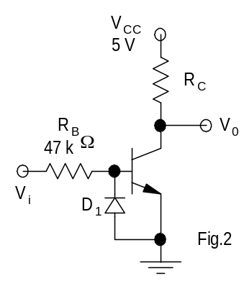Experiment
- Wire the BJT inverter circuit of Fig. 2. Use R_{C} = 1 kΩ.
- Adjust the FG to obtain a 200 Hz triangular wave (0 to +5 V) and connect the same as the input (V_{i}) to the circuit.
- Use the X-Y mode and sketch the voltage transfer characteristic (VTC − V₀ versus V_{i}) of the inverter as seen on the DSO (it should be somewhat similar to the one shown in Fig. 3). Note down the approximate values of V_{OH}, V_{OL}, V_{IL}, and V_{IH}. Indicate the modes of operation of the BJT on the different regions of the VTC.
- 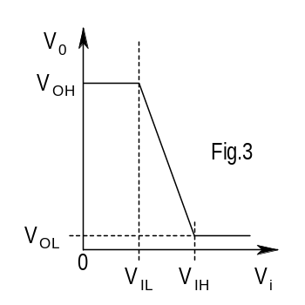Using the VTC, estimate the current gain β of the transistor.
- Now use R_{C} = 15 kΩ, and repeat steps (ii) and (iii).
- Explain the effect of R_{C} on the BJT inverter characteristic.

Note: The transistor has a low base-emitter junction reverse breakdown voltage. To ensure that this junction does not break down due to wrong polarity of the applied voltage, the diode D₁ is used – it clamps the maximum reverse bias across the junction to approximately −0.7 V.

Common Emitter Amplifier

BJT amplifiers most commonly employ the common emitter (CE) configuration. You will check the biasing conditions of the given circuit and also test the CE amplifier.

Experiment
Before coming to the lab, you should have analyzed the given BJT circuit (for R_{C} = 1.5 kΩ and 15 kΩ) and calculated the currents I_{B}, I_{C}, and I_{E}, and the voltages V_{B}, V_{C}, and V_{E}. Use β = 100, V_{BE} = 0.7 V, and V_{CEsat} = 0.2 V.
Common Emitter Amplifier using the BJT Circuit
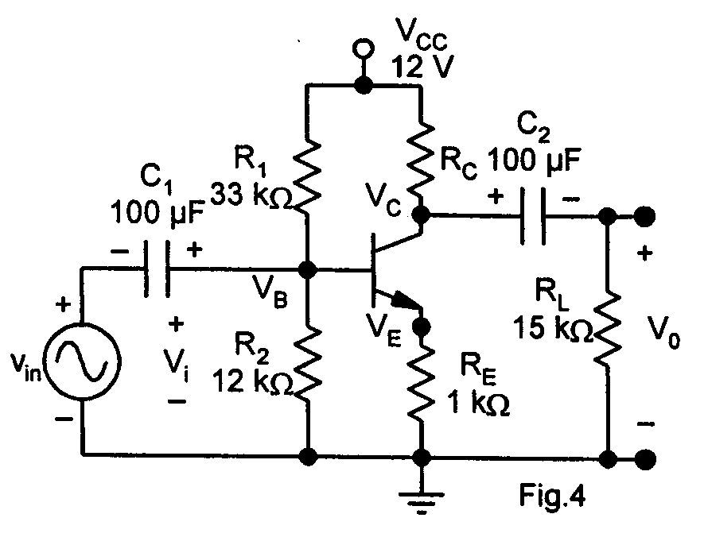
- Wire the CE amplifier circuit of Fig. 4, omitting the capacitors, R_{L}, and FG connections. Choose R_{C} = 3.3 kΩ. Make neat connections such that different points of the circuit are easily accessible.
- Measure the node voltages V_{B}, V_{C}, and V_{E} using the DMM.
- Estimate I_{B}, I_{C}, and I_{E}. Tabulate the theoretical and the measured results (Table 1).
- What is the mode of operation of the BJT? Justify your answer.

Table 1: Measured and calculated biasing conditions (R_{C} = 3.3 kΩ)
Parameter | V_{B} | V_{C} | V_{E} | I_{B} | I_{C} | I_{E} | Mode
Calculated
Measured

- Switch-off the +12V V_{CC} supply to the BJT circuit. Make R_{C}=3.3 kΩ. Now connect the electrolytic capacitors and R_{L}. Take care to observe the correct polarities when you connect the electrolytic capacitors.
- Adjust the FG output to give 0.2 sin ωt V (f=1 kHz). Switch on V_{CC} and connect the FG output to the BJT circuit through capacitor C₁.
- Observe the amplifier input (V_{i} = V_{B}) and output V_{O} on CH-1 and CH-2, respectively.
- Sketch the two waveforms. Measure the voltage gain of the amplifier (Voltage gain, A_{V} = V_{O}/V_{i}).
- Comment on the phase relationship between the amplifier input and output waveforms.

Increasing the gain of the amplifier
In order to increase the gain, an engineer decided to increase value of R_{C} to 15 kΩ.
- Change R_{C} to 15 kΩ.
- Measure the gain of the amplifier. Does it increase? If necessary, decrease the amplitude of the input signal.
- Measure the DC biasing conditions to determine the mode of operation of the BJT.

It is known from theory that the gain of the CE amplifier can be increased by connecting a capacitor in parallel with R_{E}.
- Change R_{C} back to 3.3 kΩ.
R
p1
10 k
Ω
R
p2
1 k
Ω
+
V
in
–
+
–
v
s
V
B
- Connect a 100F capacitor across R_{E}, and measure the gain. You may need to use a potential divider to reduce the amplitude of the input signal (5mV to 10mV peak) so that output signal waveform is undistorted.

Notes:
- V_{XY} = V_X – V_Y where V_X is the voltage at node X
- measured with respect to ground
- B: base, E: emitter, C: collector
- V_{BE}< 0.7 V: transistor is cutoff
- V_{BE} = 0.7 V, V_{CE}> 0.2 V: transistor is in active region
- V_{BE} = 0.7 V, V_{CE} = 0.2 V: transistor is in saturation
- I_C = beta * I_B when the transistor is in active region.
- I_E = (beta + 1) * I_B when the transistor is in active region
- Take beta = 100

